CASE 4

ECONOMETRICS/ FINANCIAL MODELLING

Tiffany Tiono

Aditya Tyagi

Gamdan Abdullah

1. 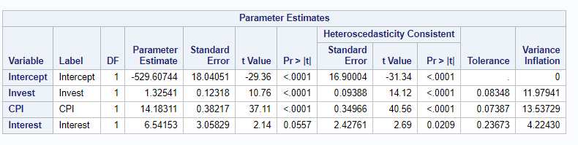**What is the population Regression function? (“GNP” is dependent, and “Invest,” “CPI” and “Interest” are independent)**

Yi = α + βInvest (Invest)+βCPI (CPI) +βInterest (Interest) +µi

Yi = -529.60744 + 1.32541(Invest)+ 14.18311(CPI) +6.54153 (Interest) +µi

**Note that the coefficient for Interest variable is not significant.**

1. **Is this regression function significant overall (state the null and alternative hypotheses and explain how you reached that conclusion)?**

H0: R2=0

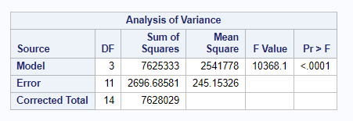Ha: R2≠0

Since the P-Value of the F-test is less than 0.05, we can reject H0 with relative confidence. Therefore, I am confident that at least one of the independent variables offers some predictability of the dependent variable in the population.

1. **Interpret the coefficient associated with “Invest.”**

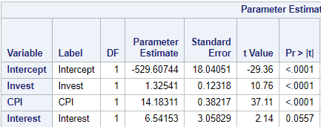

For every one-unit change in “Invest”, there is an associated 1.32541 units change on the expected GNP holding everything else in constant.

1. **Which independent variable/s offer/s ANY predictability of the dependent one (regardless of whether some of the variation is shared with other variables)? Explain.**

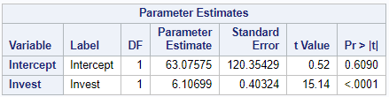

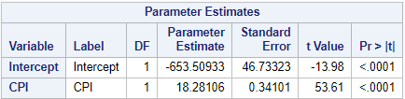

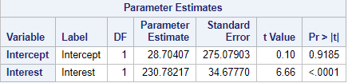

Since that these three P-values of the T-tests are less than 0.05, we can reject H0 with relative confidence. Therefore, we are confident that each of these independent variables offers some predictability of the dependent variable.

1. **Which independent variable/s offer/s any UNIQUE predictability of the dependent one? Explain.**



All P-values of the T-tests are significant except for the “Interest” variable since Invest and CPI variables that have P-values of the T-tests are less than 0.05. Therefore, we are confident that Invest and CPI are the only independent variables that offer some unique predictability of Y.

1. **How would your answers to the previous question change if you were testing significance at an α level of 10% instead of 5%?**

All P-values of the T-tests are significant since three of the independent variables have P-values of the T-tests are less than 0.1. Therefore, we are confident that Invest, CPI, and Interest are the independent variables that offer some unique predictability of Y.

1. **What proportion of the variation in the dependent variable is predictable from the set of independent variables in the sample?**

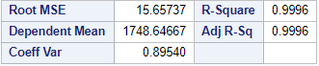

The proportion of the variation in the dependent variable is predictable from the set of independent variables in the samples is R2= **99.96%**.

1. **What is the expected GNP for a year where “Invest” = 411.7; “CPI” = 211.54; and “Interest” = 8.48? (For the sake of this exercise, do not exclude the insignificant variables from your calculation)**

Expected GNP = -529.60744 + 1.32541 (Invest) +14.18311 (CPI) + 6.54153 (Interest) + μi

Expected GNP = -529.60744 + 1.32541 (411.7) +14.18311 (211.54) + 6.54153 (8.48)

Expected GNP = **3,071.831121**

1. **Test your model for Multicollinearity using the Condition Index Method.**

In order to test our model for multicollinearity, we use the result from the SAS output while using the Condition Index Method.

The Condition Index= $\sqrt{\frac{MaximumEigenvalue}{MinimumEigenvalue}}$

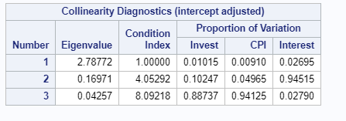

Based on the results, the Conditional Index equals to $\sqrt{\frac{2.78772}{0.04257}}=8.0923$

Since the Conditional Index is less than 10, we do not find any evidence of multicollinearity in our model.

1. **Test your model for Multicollinearity using the VIF Method.**

In order to determine if this model has multicollinearity, we need to compare all the values under the VIF section to the models VIF.

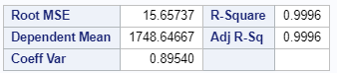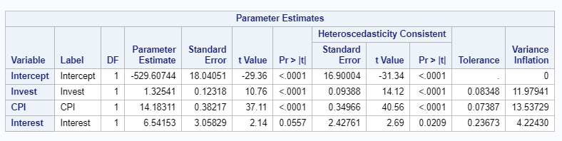

The Model’s VIF = $\frac{1}{1-R^{2}}$ = $\frac{1}{1-0.9996}=$ 2,500

Since, there is none of the VIF values exceeds the model’s VIF, which shows that the independent variables are not more closely related to each other to the dependent variable. Therefore, we conclude that our model does not have a strong multicollinearity problem.

1. **Test your model for Heteroskedasticity using the White’s Test.**

H0: Our model suffers from Homoskedasticity

Ha: Our model suffers from Heteroskedasticity

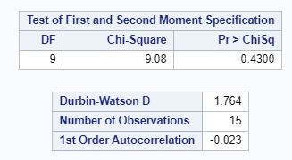

Since the P-value from the White’s test is greater than 0.05, we fail to reject the null hypothesis in relative confidence. Therefore, we can’t fairly certain that our model suffers from Heteroskedasticity.

1. **Generate the Heteroskedasticity-consistent P-values.**



1. **Test your model for Autocorrelation using the Durbin-Watson Test.**

H0: Our model has no First-Order Autocorrelation

Ha: Our model has First-Order Autocorrelation

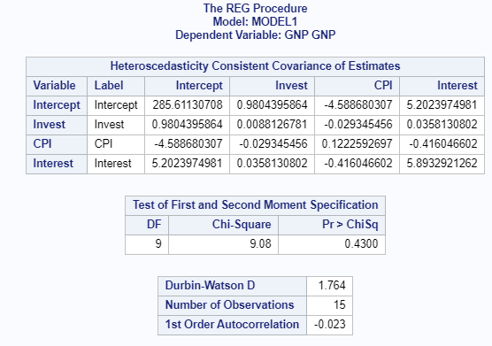

Based on the results from SAS, the P-value for the Durbin-Watson test is 1.764.

We have the following information below:

α = 0.05

n = 15

k = 3

We need to calculate:

DLower = 0.82 and DUpper = 1.75

Since the P-value of Durbin-Watson Test is between 1.75(dupper) and 2.25(4- dupper), we fail to reject the null hypothesis. Thus, we can’t fairly certain that our model has no First-Order Autocorrelation.

1. **Provide the full SAS code used.**

